X86 tfserving  
安装：

1、Install Tensorflow Serving using Docker (Recommended)  
2、Install Tensorflow Serving without Docker (Not Recommended)  
3、Deploy Tensorflow Serving on Kubernetes

1. Install Tensorflow Serving using Docker (Recommended)

x86

1. 安装

sudo docker pull tensorflow/serving

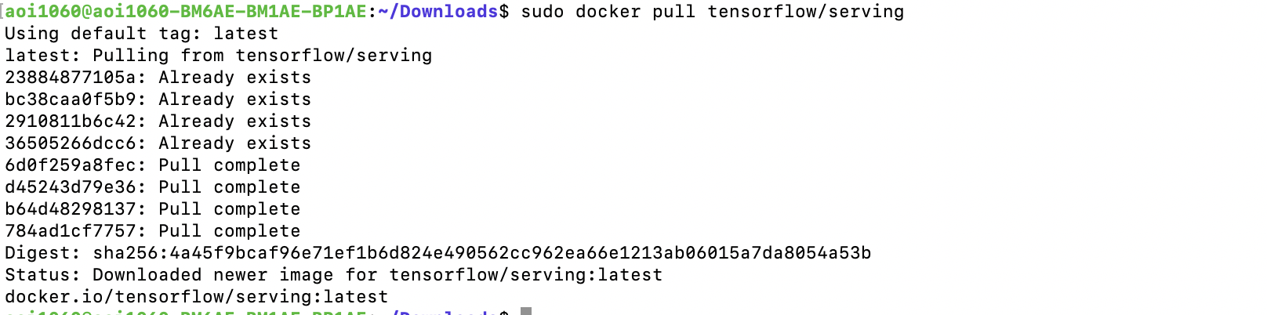

1. 部署模型

TESTDATA="$(pwd)/serving/tensorflow_serving/servables/tensorflow/testdata"

sudo docker run -t --rm -p 8501:8501 -v "$TESTDATA/saved_model_half_plus_two_cpu:/models/half_plus_two" -e MODEL_NAME=half_plus_two tensorflow/serving &

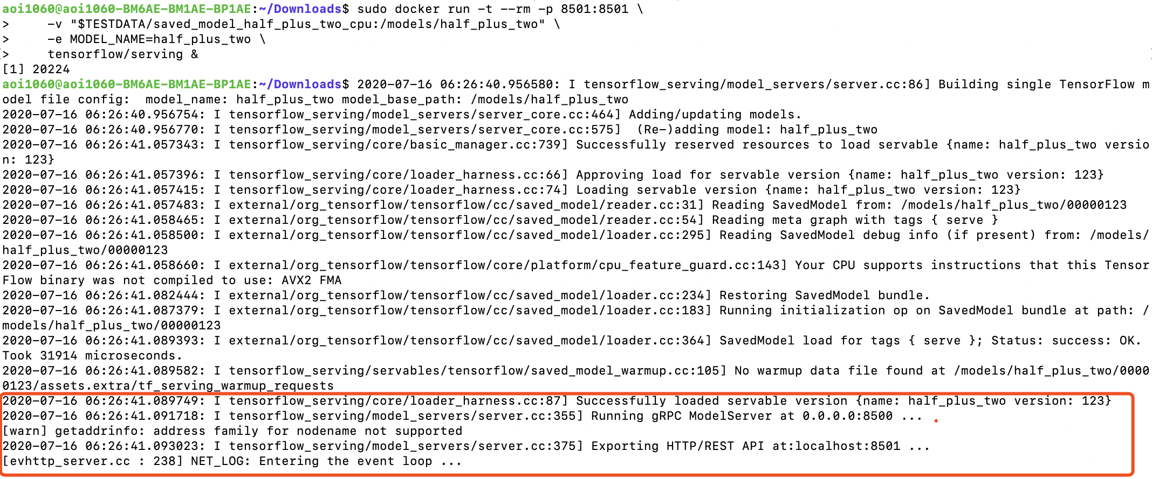

1. 测试

curl -d '{"instances": [1.0, 2.0, 5.0]}' -X POST http://localhost:8501/v1/models/half_plus_two:predict

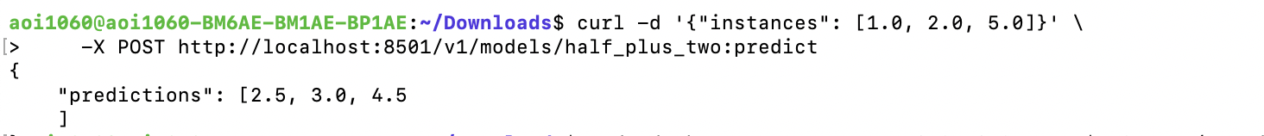

IPC

1. 安装

sudo docker pull tensorflow/serving

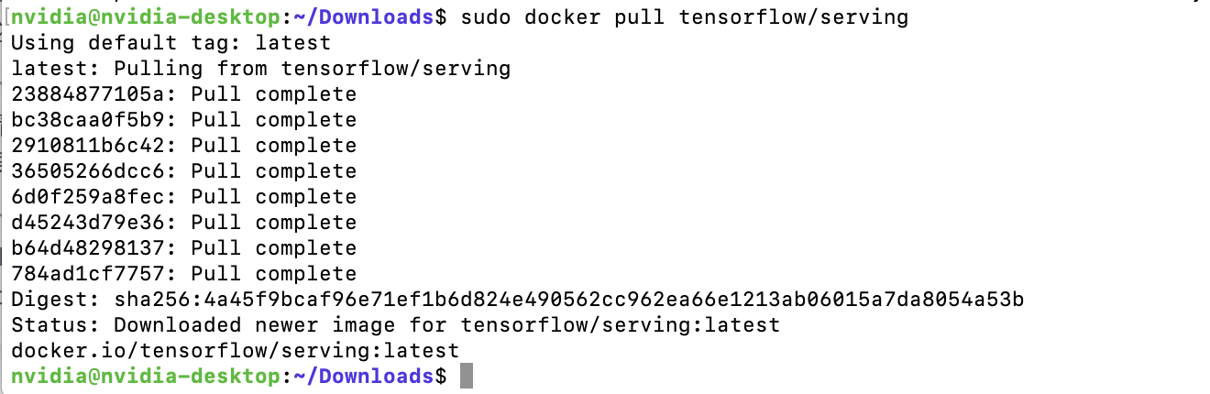

2、部署模型

TESTDATA="$(pwd)/serving/tensorflow_serving/servables/tensorflow/testdata"

sudo docker run -t --rm -p 8509:8509 -v "$TESTDATA/saved_model_half_plus_two_cpu:/models/half_plus_two" -e MODEL_NAME=half_plus_two tensorflow/serving &

error: standard_init_linux.go:211: exec user process caused "exec format error"



1. Install Tensorflow Serving without Docker (Not Recommended)

X86

1、添加TensorFlow服务分发URI作为包源

echo "deb [arch=amd64] http://storage.googleapis.com/tensorflow-serving-apt stable tensorflow-model-server tensorflow-model-server-universal" | sudo tee /etc/apt/sources.list.d/tensorflow-serving.list && \

curl https://storage.googleapis.com/tensorflow-serving-apt/tensorflow-serving.release.pub.gpg | sudo apt-key add -

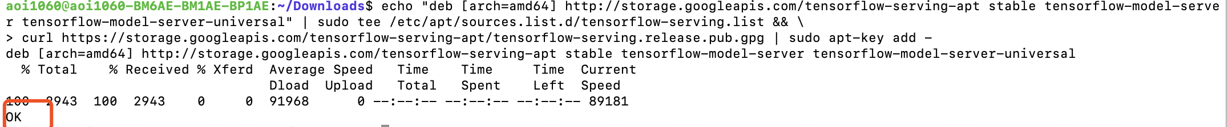

2、安装TensorFlow ModelServer

pip3 install tensorflow-serving-api

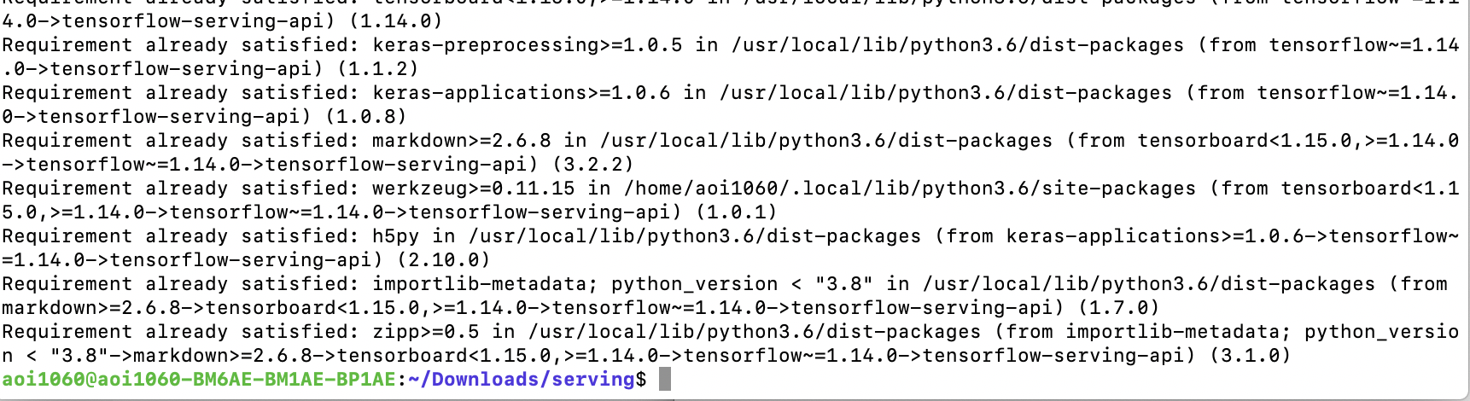3、apt-get install tensorflow-model-server

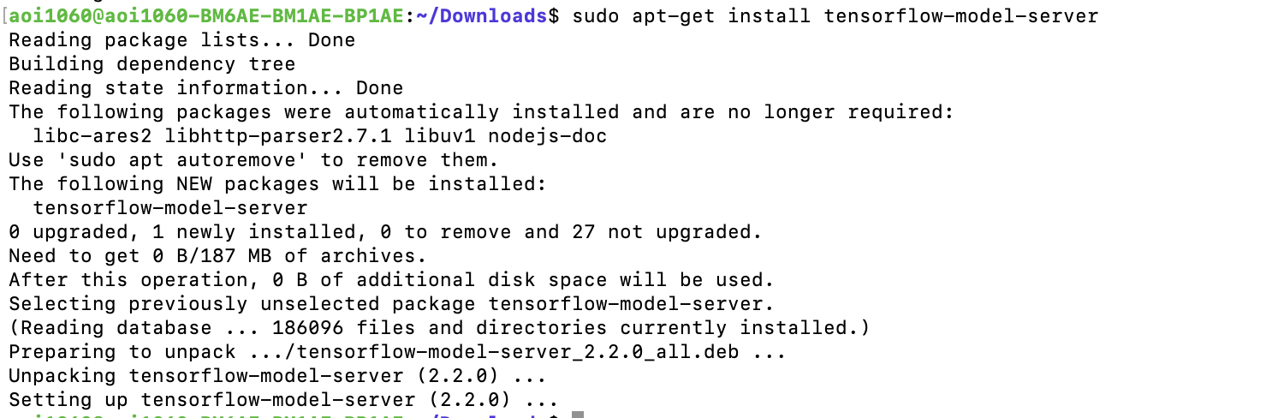

4、部署模型

tensorflow_model_server --port=8500 --model_name=mnist --model_base_path=/home/aoi1060/Downloads/serving/tmp/mnist_model/ &

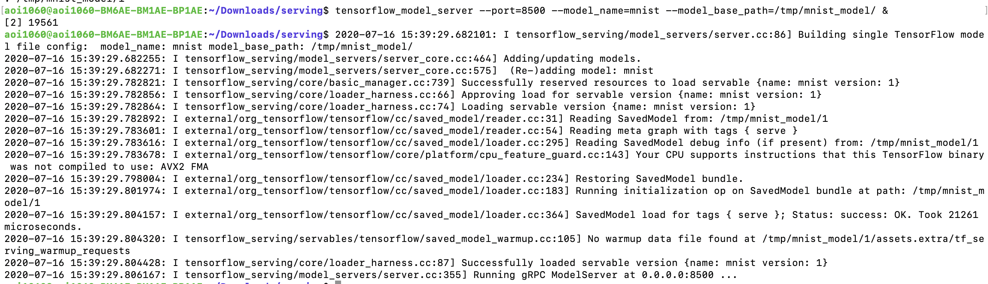

5、测试

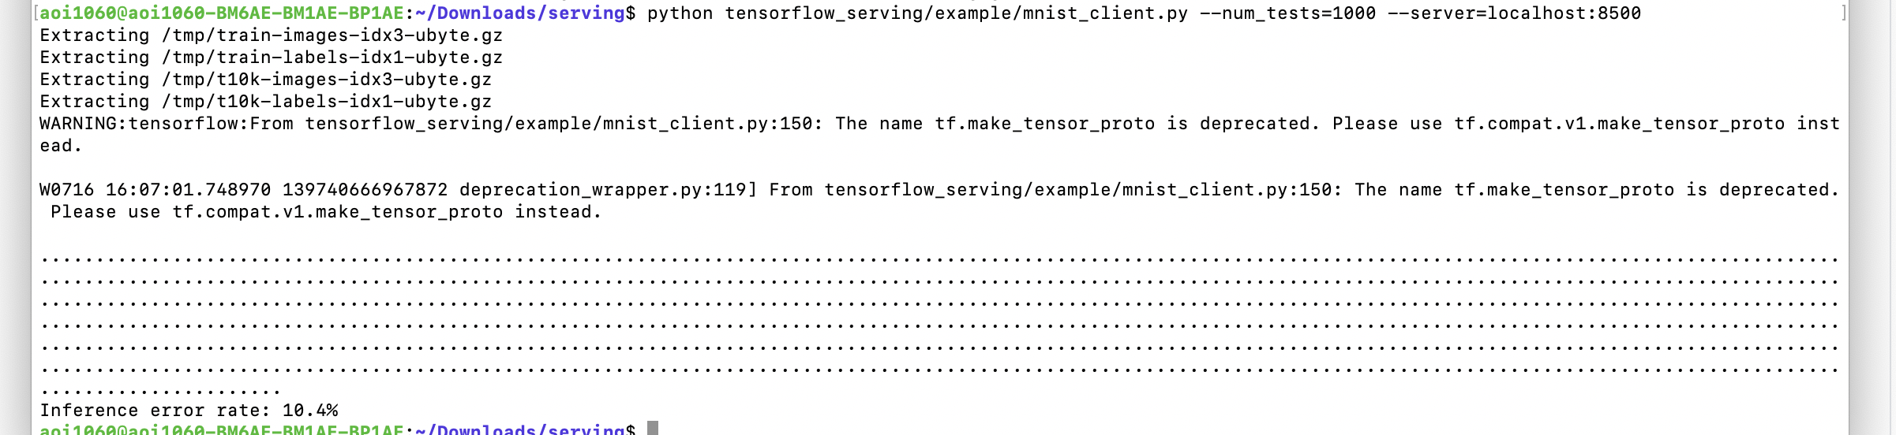

IPC

1、添加TensorFlow服务分发URI作为包源

echo "deb [arch=amd64] http://storage.googleapis.com/tensorflow-serving-apt stable tensorflow-model-server tensorflow-model-server-universal" | sudo tee /etc/apt/sources.list.d/tensorflow-serving.list && \

curl https://storage.googleapis.com/tensorflow-serving-apt/tensorflow-serving.release.pub.gpg | sudo apt-key add -

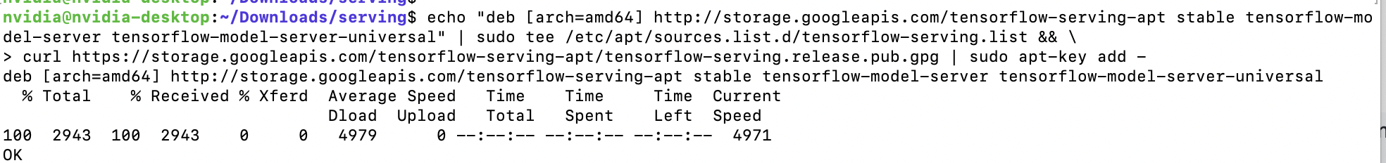

2、安装TensorFlow ModelServer

pip3 install tensorflow-serving-api

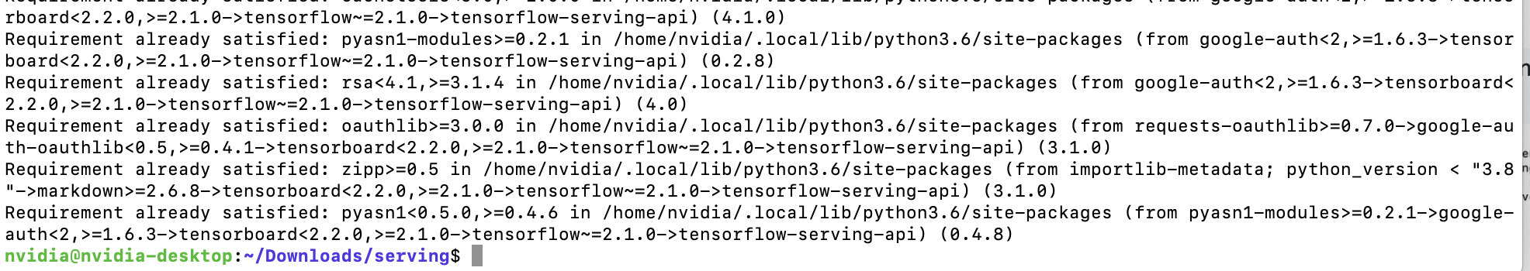

3、apt-get install tensorflow-model-server

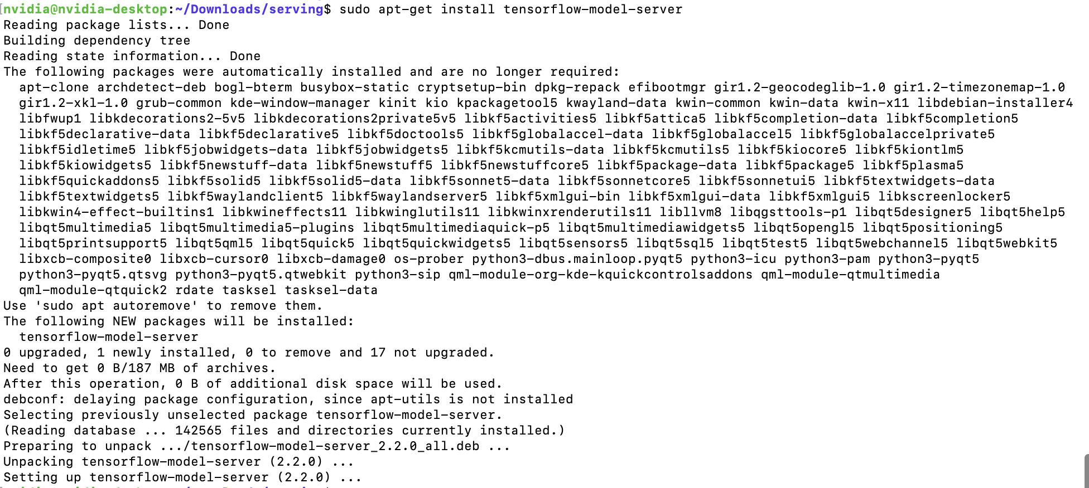

4、部署模型

tensorflow_model_server --port=8500 --model_name=mnist --model_base_path= /home/aoi1060/Downloads/serving/tmp/mnist_model/ &

error: -bash: /usr/bin/tensorflow_model_server: cannot execute binary file: Exec format error



1. Deploy Tensorflow Serving on Kubernetes

X86

1. 建立一个tensorflow/serving服务容器

sudo docker run -d --name serving_base tensorflow/serving

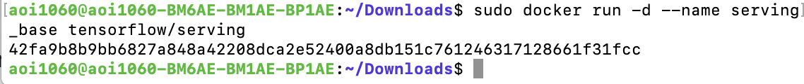



1. 将文件放入容器中

sudo docker cp /tmp/resnet serving_base:/models/resnet

1. 从serving_base容器中创建一个新的image

sudo docker commit --change "resnet" serving_base resnet_serving

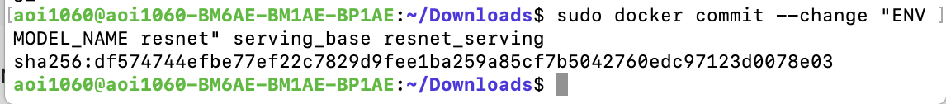

1. 运行resnet_serving镜像

sudo docker run -p 8500:8500 -t resnet_serving &

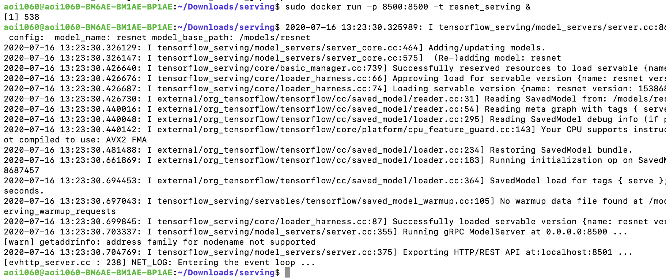

IPC

1、建立一个tensorflow/serving服务容器

sudo docker run -d --name serving_base tensorflow/serving



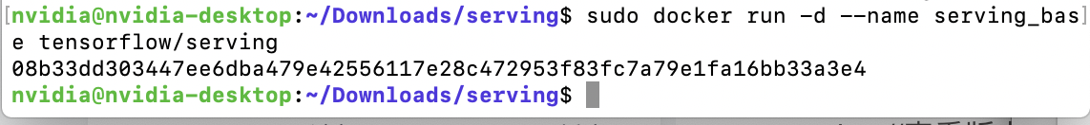

error: standard_init_linux.go:211: exec user process caused "exec format error"

